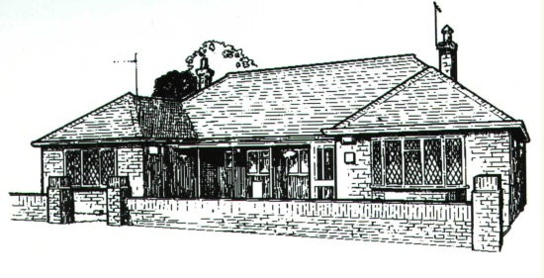
St Peters Surgery
6-8 Oaklands Avenue
St Peters
Broadstairs CT102SQ

Registering for Patient Access
To register for online services please complete this form and return it to your Practice. Once your registration has been completed by the Surgery you will be issued with a user ID and Password.
Patient Details
Please complete in BLOCK CAPITALS

Forename

Date of Birth
Surname
Email Address: This will be used by your practice to send reminders

Mobile Number

I wish to access my medical records online and understand and agree with each statement below
- I will be responsible for the security of the information that I see or download
- If I choose to share my information with anyone else, this is at my own risk
- If I see any information on my record that is inaccurate I will contact the practice
as soon as possible

Signed……………………………………………………………………………Dated……………………………………………

